Multicultural Access and Equity Action Plan 2016-17



# Our vision for Multicultural Access and Equity

The Department of Social Services (DSS) recognises the rich diversity of Australia’s multicultural society and the valuable contribution that people from different cultural and linguistic backgrounds make to our nation.

DSS’ vision for multicultural access and equity is to achieve fair and accessible government programs and services for all clients, so that everyone can participate in our society and become established members of it.

We strive to embed multicultural access and equity considerations in our policies, programs and services to ensure they meet needs of all eligible Australians, irrespective of cultural or linguistic background.

In our role as lead agency with responsibility for coordination of the Multicultural Access and Equity Policy, we are committed to assisting Australian Government departments and agencies to understand their obligations and implement meaningful change.



# Our department

DSS aspires to be Australia’s pre-eminent social policy agency.

Our mission is to improve the lifetime wellbeing of people and families in Australia.

The work we do reflects the four core areas in which the Department seeks to assist people:

**Social Security**

Ensure financial support for individuals and families who are unable to fully support themselves by providing a sustainable payments and concessions system.

**Families and Communities**

Promote stronger families and more resilient communities by developing civil society and by providing family and community services.

**Housing**

Increase housing supply, improve community housing and assist individuals experiencing homelessness through targeted support and services.

**Disability and Carers** Promote improved independence of, and participation by, people with disability, including improved support for carers, by providing targeted support and services.

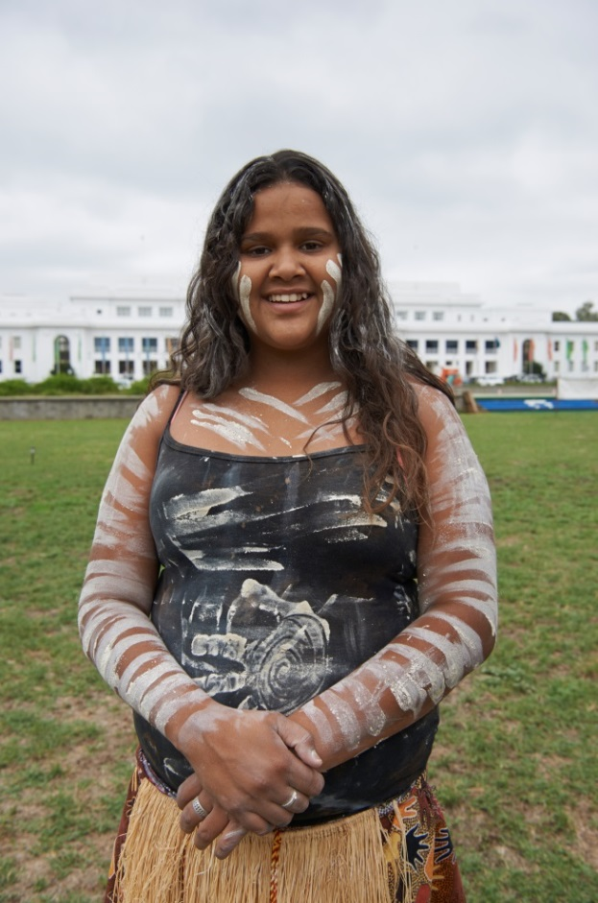

Our work affects the lives of millions of Australians, including those from culturally and linguistically diverse backgrounds. We have many different clients and stakeholders with high levels of diversity.

To achieve our purpose, we acknowledge that the design and delivery of our policies, programs and services must recognise and respond to the multicultural character of the community we serve.

The Department currently supports and engages with Australians from culturally and linguistically diverse backgrounds through a range of initiatives, including but not limited to:

**Multicultural Liaison Officer Network**

The Department’s Network of Multicultural Community Liaison Officers (MCLO) develop productive and collaborative relationships with CALD communities and key stakeholders to strengthen linkages to the Australian Government and support a productive and diverse society for all Australians.  MCLOs help to strengthen and empower CALD communities to increase their independence, economic and social participation, and general wellbeing.

**Harmony Day**

[Harmony Day](http://www.harmony.gov.au/) is held annually on 21 March. It is a community event, created by the Australian Government, coinciding with the United Nations International Day for the Elimination of Racial Discrimination. Harmony Day is a day to celebrate Australia’s cultural diversity, and promote the message that everyone belongs. Since 1999, a variety of groups including sporting organisations, community groups, local government, churches, schools and businesses have staged more than 60 000 Harmony Day events.

**Australian Multicultural Council**

The Department provides secretariat support to the [Australian Multicultural Council](https://www.dss.gov.au/our-responsibilities/settlement-and-multicultural-affairs/programs-policy/a-multicultural-australia/australian-multicultural-council), which is a ministerially-appointed body that provides advice to Government on multicultural affairs policy and programs. Through their terms of reference, the Council aims to support all Australians – including those from culturally and linguistically diverse backgrounds – to fully participate in Australian life, to celebrate diversity and build stronger and more cohesive communities.

**Reducing violence against women**

We administer a number of CALD focussed initiatives under the *National Plan to Reduce Violence against Women and their Children 2010-2022*, including:

* funding White Ribbon Australia to increase its engagement with CALD and Indigenous communities;
* extending DV-alert training to settlement workers;
* researching diverse experiences of violence;
* releasing the Hearing Her Voice report after engaging widely with CALD women and communities;
* releasing the Platform For Action report after supporting Australia’s first national roundtable on responding to violence against CALD women and their children;
* developing the Family Safety Pack with information on Australia’s laws and a woman’s right to be safe; and
* administering the Support for Trafficked People Program, for victims of human trafficking and slavery, including forced labour and forced marriage.

**Federation of Ethnic Communities’ Councils of Australia**

We provide funding to the Federation of Ethnic Communities’ Councils of Australia (FECCA) as the peak, national body representing Australians from CALD backgrounds. FECCA promotes issues on behalf of its constituency, to Government, business and the broader community. A key component of its annual work plan with DSS is to conduct consultations with CALD communities to gather feedback on government service delivery.

# Our Multicultural Access and Equity Action Plan

The Department’s Multicultural Access and Equity Action Plan 2016-17 sets out the steps we will take to improve our responsiveness to Australia’s cultural and linguistic diversity.

It was developed through consultation with key areas of the department, including our service delivery network. The actions it contains give practical effect to the six commitments of the Multicultural Access and Equity Policy: Leadership; Engagement; Responsiveness; Performance; Capability and Openness.

A particular focus of the plan is on supporting our staff to develop an understanding of multicultural access and equity principles to ensure they become an integrated part of our work culture. We seek to achieve this goal though the implementation of cultural competency training and a department-wide communications and engagement strategy.

Performance against the plan will be monitored by the DSS Multicultural Access and Equity Committee.

Leadership
Australian Government departments and agencies will demonstrate a commitment to multicultural access and equity and take responsibility for its implementation.
Engagement
Australian Government departments and agencies will identify and strategically engage with culturally and linguistically diverse clients, stakeholders and communities.
Responsiveness
Australian Government departments and agencies will have strategies in place to ensure that policies, programmes, community interactions and service delivery (whether in-house or outsourced) are responsive to culturally and linguistically diverse Australians.
Performance
Australian Government departments and agencies will have strong and clear mechanisms in place to measure their multicultural access and equity performance.
Capability 
Australian Government departments and agencies will understand, and have the capacity to respond to, the cultural and linguistic diversity of Australia’s population.
Openness
Australian Government departments and agencies will be transparent in their implementation of multicultural access and equity.

# Our actions

**Commitment 1: Leadership**

Demonstrate a commitment to multicultural access and equity and take responsibility for its implementation

| Item | Action | Responsibility | Timeline | Target |
| --- | --- | --- | --- | --- |
| 1.1 | Continue Senior Executive Officer as DSS Multicultural Access and Equity Champion to promote multicultural access and equity priorities across the Department. | Multicultural and Communities Branch | March 2017 | Senior Executive Officer appointed. |
| 1.2 | Maintain the DSS Multicultural Access and Equity Committee to monitor implementation of this Action Plan. | Lead: Chair, DSS Multicultural Access and Equity Committee  Supported by: Multicultural and Communities Branch | From July 2016 | Committee meets at least twice in  2016-17. |
| 1.3 | Provide guidance on incorporating the Department’s commitment to multicultural access and equity into corporate strategic and business planning documents. | Ministerial, Parliamentary and Executive Support Branch | From July 2016 | Key corporate documents state the Department’s commitment to multicultural access and equity. |
| 1.4 | As the lead agency for the Multicultural Access and Equity Policy, support Australian Government agencies, including DSS, to implement and report on their multicultural access and equity activities. | Multicultural and Communities Branch | Ongoing work | Updated Policy Guide, Assessment Tool, Sample Planning Template, Reporting Timeline are available to Australian Government agencies.  Multicultural Access and Equity Interagency Support Group to meet at least two times in 2016-17.  Helpline and mailbox available to answer queries from staff regarding multicultural access and equity issues. |

**Commitment 2: Engagement**

Identify and strategically engage with CALD clients, stakeholders and communities

| Item | Action | Responsibility | Timeline | Target |
| --- | --- | --- | --- | --- |
| 2.1 | Deliver a Multicultural Community Liaison Officer Network to engage with CALD communities, with priority given to high risk and emerging communities. | Delivery Network | Ongoing work | Multicultural Community Liaison Officers (MCLOs) engage effectively with multicultural communities. |
| 2.2 | MCLOs identify and escalate issues faced by CALD communities accessing mainstream services to relevant stakeholders. | Delivery Network | Ongoing work, to be reviewed in December 2016 | MCLOs provide timely Intelligence Reports to Policy Branches on multicultural access and equity issues. |
| 2.3 | Grant Managers/Contract Managers engage with DSS funded service providers to identify and escalate issues faced by CALD communities accessing mainstream services to relevant stakeholders. | Delivery Network | Ongoing work | DSS Grant Managers and MCLOs to provide Intelligence (in an agreed format) to Policy Branches on multicultural access and equity issues. |
| 2.4 | Commission the Federation of Ethnic Communities’ Councils of Australia (FECCA) to provide structured feedback from CALD communities on their perceptions of multicultural access and equity in government services. | Multicultural and Communities Branch | By June 2017 | Community consultations held. Findings reported to the Department. |
| 2.5 | Engage with CALD women and communities to prevent and respond to violence against women and their children. | Family Safety Branch | Ongoing work | Implement the Third Action Plan of the *National Plan to Reduce Violence Against Women and their Children 2010-2022*. |

**Commitment 3: Responsiveness**

Strategies are in place to ensure that policies, programs, community interactions and service delivery (whether in-house or outsourced) are responsive to CALD Australians

| Item | Action | Responsibility | Timeline | Target |
| --- | --- | --- | --- | --- |
| 3.1 | Develop approaches to support local community and specialist organisations navigate grant application processes. | Program Office | June 2017 | Work with community sector representatives to improve access to grant information and processes.  Delivery to provide timely input to support the identification of issues re: CALD access to grants processes.  Support Program Office Delivery and Policy Officers to communicate in plain English including the development of Plain English documents. |
| 3.2 | Review priority and high traffic pages of the DSS website regarding accessibility for people with low English language proficiency. | Lead: Application Delivery Branch  Supported by: Communication and Media Branch and Multicultural and Communities Branch | June 2017 | Review of high volume website pages complete. Recommendations for improvements to the highest volume pages implemented.  Delivery to provide timely input to support the identification of issues re: CALD access to grants processes. |
| 3.3 | Continue to be an active member of the DHS led Multicultural Access and Equity working group. | Lead: Multicultural, Settlement Services and Communities | Ongoing | Attend meetings as required and implement actions. |

**Commitment 4: Performance**

Australian Government departments and agencies will have strong and clear mechanisms in place to measure their multicultural access and equity performance

| Item | Action | Responsibility | Timeline | Target |
| --- | --- | --- | --- | --- |
| 4.1 | Develop Key Performance Indicators (KPIs) relating to engagement with, and outcomes of services for CALD clients. | Policy Systems Branch | June 2017 | KPIs are included in the Department’s 2016-17 Corporate Plan. |
| 4.2 | Report on the implementation of this Action Plan to the Department’s Senior Management. | Lead: Chair, DSS Multicultural Access and Equity Committee  Supported by: Multicultural and Communities Branch | Second half of June 2017 | Implementation Report provided to the DSS Executive Management Group. |



**Commitment 5: Capability**

Australian Government departments and agencies will understand, and have the capacity to respond to, the cultural, linguistic diversity of Australia’s population

| Item | Action | Responsibility | Timeline | Target |
| --- | --- | --- | --- | --- |
| 5.1 | Develop and implement an internal Communications and Engagement strategy to improve staff understanding of multicultural access and equity obligations and cultural awareness. | Lead: Communication Services Branch  Supported by: Multicultural and Communities Branch | Strategy to be developed in 2016-2017.  Implementation commenced 2017.  Strategy to be reviewed late 2017. | Strategy developed and implemented. |
| 5.2 | Investigate options for cultural competency training for DSS staff. | Lead: People Branch  Supported by: Multicultural and Communities Branch | July 2017 | Identify cultural competency training module and implement pilot. |
| 5.3 | Implement ‘Access and Equity in mainstream services overview’ training for MCLOs and other relevant staff. | Delivery Network | Ongoing work | ‘Access and Equity in mainstream services overview’ training implemented. |

**Commitment 6: Openness**

Australian Government departments and agencies will be transparent in their implementation of multicultural access and equity

| Item | Action | Responsibility | Timeline | Target |
| --- | --- | --- | --- | --- |
| 6.1 | Publish this Action Plan on the Department’s website. | Multicultural and Communities Branch | Early 2017 | Action Plan published on the DSS website. |
| 6.2 | As the lead agency for the Multicultural Access and Equity Policy, prepare a report on Australian Government agencies’ progress in implementing the policy for tabling in Parliament. | Multicultural and Communities Branch | December 2016 | 2013-2015 report prepared for tabling in Parliament. |
| 6.3 | Work with the Australian Bureau of Statistics to share and improve cultural and linguistic data with other agencies and stakeholders. | Multicultural and Communities Branch | March 2017 | Better practice guide on CALD data for Australian Government departments and agencies completed and distributed. |
| 6.4 | Conduct an audit of CALD data collected across DSS, seeking information/data that could inform and improve multicultural access and equity performance. | Policy Evidence Branch | Audit commenced by December 2016.  Completed by June 2017. | Improved migrant, humanitarian and ethnicity related statistics available.  Relevant datasets available for analysis. |

Contact

For feedback or to find out more information, please contact:

Multicultural Policy

Helpline: 1300 792 343

Email: accessandequity@dss.gov.au

Web: [hwww.dss.gov.au](https://www.dss.gov.au/)